Python Data types

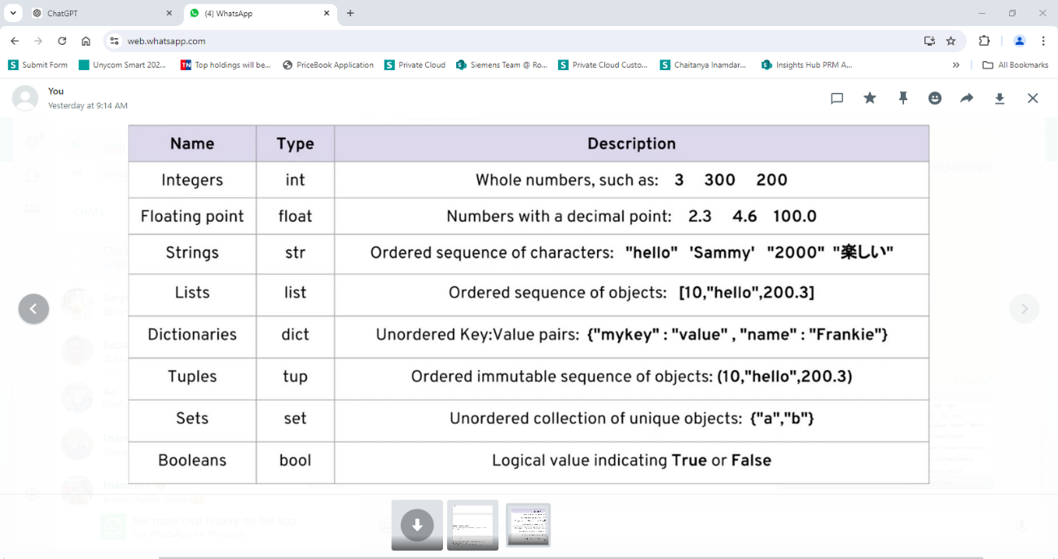

1. What is meant by ordered/unordered?
2. What is meant by mutable/ immutable?

**Strings**:

1. Commenting –
2. String concatenation –
3. String length –

Write a program that accepts First name, Middle name and Last name and prints the full name.

|  |
| --- |
| # String Data Type |
| name = "Alice" |
| print("Hello, " + name + "!") |
| # String concatenation |
| first_name = "John" |
| last_name = "Doe" |
| full_name = first_name + " " + last_name |
| print("Full Name: " + full_name) |
| # String Length |
| message = "Python is fun!" |
| print("The length of the message is:", len(message)) |

**Int and Floats:**

1. Basic arithmetic operations

Write a program that does arithmetic operations on 2 values prints all the results.

|  |
| --- |
| # Integer Data Type |
| a = 5 |
| b = 3 |
| print("Addition:", a + b) |
| print("Subtraction:", a - b) |
| print("Multiplication:", a * b) |
| print("Division:", a / b) |
| # Float Data Type |
| c = 5.5 |
| d = 2.2 |
| print("Float Addition:", c + d) |
| print("Float Subtraction:", c - d) |

**Lists**:

1. List data type uses.
2. Accessing using Indexers
3. Adding elements to the list
4. Removing elements from the list

Write a program to accept a user’s shopping list and print it if he has finished adding the elements.

|  |
| --- |
| # List Data Type |
| fruits = ["apple", "banana", "cherry"] |
| print("Fruits:", fruits) |
| # Accessing List Elements |
| print("First fruit:", fruits[0]) |
| print("Second fruit:", fruits[1]) |
| # Adding Elements to a List |
| fruits.append("orange") |
| print("Fruits after adding orange:", fruits) |
|  |
| # Removing Elements from a List |
| fruits.remove("banana") |
| print("Fruits after removing banana:", fruits) |

**Tuple:**

1. Tuple data type
2. Accessing tuple elements – indexers
3. Tuples are immutable – different than lists

Program – that checks if Tuples are immutable.

|  |
| --- |
| # Tuple Data Type |
| colors = ("red", "green", "blue") |
| print("Colors:", colors) |
|  |
| # Accessing Tuple Elements |
| print("First color:", colors[0]) |
| print("Second color:", colors[1]) |
| # Tuples are immutable |
| # This will cause an error: |
| # colors[0] = "yellow" |

**Dictionary:**

1. Dictionary Data type
2. Accessing elements in a dictionary
3. Adding elements to a dictionary
4. Removing elements

Write a program to create a dictionary which stores student information.

|  |
| --- |
| # Dictionary Data Type |
| student = { |
| "name": "Alice", |
| "age": 12, |
| "grade": "7th" |
| } |
| print("Student Info:", student) |
| # Accessing Dictionary Elements |
| print("Name:", student["name"]) |
| print("Age:", student["age"]) |
| # Adding Elements to a Dictionary |
| student["school"] = "Greenwood High" |
| print("Student Info after adding school:", student) |
| # Removing Elements from a Dictionary |
| del student["age"] |